Section 6.1 - One Step Inequalities

Draw a number line, and shade all the numbers that satisfy the following inequalities. Give the interval notation also

a) x > 3

b) x ≤ 4

c) x ≥ 0

Give the inequality and the interval notation for the following
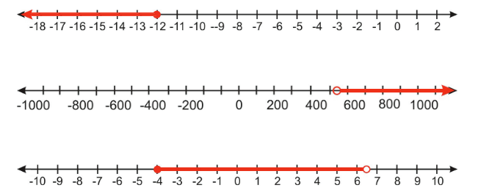

Solve and graph:

x - 3 < 10

x - 20 ≥ 14

x + 8 < −7

How about multiplication... try solving and checking these

2x ≥ 12

−3x < 9

When solving an inequality, multiplying or dividing by a negative number causes the inequality to change direction.

Section 6.2 - Multi-step Inequalities
Solve and graph

6x - 5 < 10

−9x ≤ −5x−15

−9x ≤ 24

−25x+12 < −10x−12

Other possible scenarios

Solve and graph

x − 5 > x + 6

3x - 2 ≤ 3(x - 3) + 2

Solve
3x + 5 - 2 ≤ 4(x + 1) - (x + 1)

Interval notation for multiple intervals
Give the interval notation for this graph
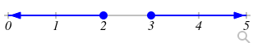

In order to get a bonus this month, Leon must sell at least 120 newspaper subscriptions. He sold 85 subscriptions in the first three weeks of the month. How many subscriptions must Leon sell in the last week of the month?

Virena’s Scout Troup is trying to raise at least $650 this spring. How many boxes of cookies must they sell at $4.50 per box in order to reach their goal?
Section 6.6 - Linear Inequalities in Two Variables
We're not covering absolute value inequalities in this class (so you can skip that part of the book)

Graph y=2x - 1 and plot them in a color determined by which equation/inequality they satisfy
(0, -1)
(1, 1)
(0, 1)
(1, 4)
(4, 0)
(-4, 0)
(1, -1)

If you don't have colors, use the symbol in parentheses instead
y = 2x - 1 -> plot with pencil (a triangle)
y > 2x - 1 -> plot in blue (an x)
y < 2x - 1 -> plot in red (a square)

Based on what you see, predict which symbol you would use for (-1, -1)
Example of y > mx + b

Example of y ≥ mx + b

When do we use a solid line?

When do we use a dashed line?

Graph 3x - 2y > 6

General technique of graphing inequalities
1. Graph the boundary line (dashed vs solid line)

2. Shade one side of the line (Determine with slope-intercept form, or use a test point)
Graph 5x - 2y > 4

Graph

A coffee blend is made by mixing two types of coffee beans. One type costs $9 per pound and another type costs $7 per pound. Find all the possible mixtures of weights of the two different coffee beans for which the blend costs $8.50 per pound or less.

Julian has a job as an appliance salesman. He earns a commission of $60 for each washing machine he sells and $130 for each refrigerator he sells. How many washing machines and refrigerators must Julian sell in order to make $1000 or more in commission?
Graph the following on a rectangular coordinate plane

x < 20

y ≥ -5

6x+5y > 1

